Guidelines for MCCC Scribes, Readers, and Examinees
The role of scribes, readers, and examinees is very important to the test accommodation process. All of these roles should be taken seriously by the persons facilitating them. The role of the scribe is to take down in writing “what is dictated by the student, no more and no less”. Readers are assigned to read tests aloud to students who may have reading difficulties. The role of the Reader is simply to read the test aloud to the student, not explain or interpret the test. The following guidelines outline the responsibilities of each of the above:

Scribes
- Scribes are expected to arrive at the testing site a few minutes before the designated test time.
- Scribes are only to write down what is dictated, no more and no less.
- Scribes should strongly suggest that student read/review what the scribe has written for each entry on the test before turning it in.

Readers
- Readers are expected to arrive at the testing site a few minutes before the designated test time.
- All exams should be read with even inflection throughout so that examinees do not receive any clues by the way the information is read. When asked, readers may reread questions as many times as necessary within the allotted testing time.
- Readers are simply to read what is written; readers should not interpret what is written.
- The reader should not answer questions from the examinee about the material he/she is reading to the student. If the student persists in asking for clarification from the reader, the reader should notify the Testing Center staff immediately.
Examinees
- Examinees are not to ask the reader/scribe for answers or assistance in answering test questions. If such requests arise, the reader/scribe will notify the Testing Center staff and corrective measures will be taken. If the examinee persists in asking for clarification, it may result in termination of the test.
- After the reader reads a question, the examinee must give a response, a request to reread the question, or a request to defer the question to a later time.
- The Examinee may ask the reader scribe to reread any question at the end of the test if it is within the allotted time limit.

Monitoring of the Exam
- Monitoring of the exam will be done by a staff professional. This is to ensure that the testing accommodations are being offered according to established procedures for test accommodations.
- Unless otherwise indicated by the instructor, all tests will be closed book/note tests. All extra materials must be placed at the testing desk.

Things to Remember
- Working as a scribe, reader, or examinee is a very serious job. You are, in ways, responsible for another student’s academic progress. When interacting with students during testing, you are expected to perform your work with extreme professionalism. Joking, jesting, or inappropriate casual conversation during the test is not permitted. The student needs to have the best possible environment to complete the test.
- You are expected to arrive at the LAL before the designated test time. This will give opportunity for you to meet the student and also to receive any pertinent instructions from the Testing staff. Late arrival will result in the termination of your services.
- You are not to question the student concerning his/her disability or why he receives the services he/she does. You may ask information related to the facilitation of the test if needed (i.e. Am I reading too fast for you?).

For questions, please contact:

Disability Services
Located in the Student Success Center in Founders Hall
(734) 384-4167

GUIDELINES FOR MCCC
- READERS
- SCRIBES
- EXAMINEES

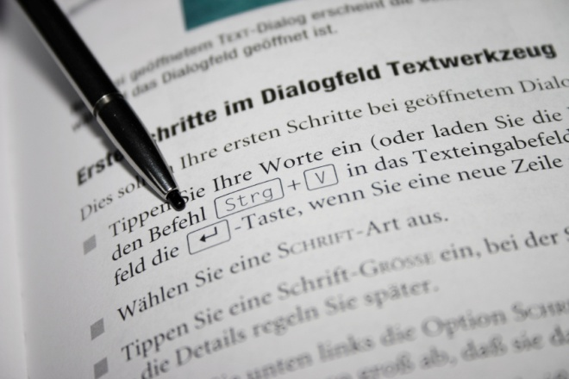

MONROE COUNTY COMMUNITY COLLEGE
1555 SOUTH RAISINVILLE RD.
MONROE MICHIGAN 48161-9746

