

**IMPORTANT INFORMATION FOR**

STUDENTS WITH DISABILITIES

ADA/Section 504

Procedures for Requesting Accommodations Procedures for Filing a Complaint



## INVESTIGATION AND RESOLUTION

Upon receipt of the complaint, the student ADA compliance officer/vice president of enrollment and student success will conduct an investigation into the alleged complaint. All parties related to the complaint will be afforded opportunity to submit evidence (including statements from witnesses) relevant to the complaint. The investigation will be completed within 10 business days and a resolution will be issued by the ADA compliance officer/vice president of enrollment and student success.

## APPEAL

The complainant may request reconsideration of the complaint in the form of an appeal if the student is dissatisfied with the outcome of the resolution. A written request for reconsideration of the outcome of the resolution should be filed in the Office of the President within five business days of receipt of the original resolution. The president will review the

request and issue a final resolution within 10 business days. The Office of the President is located in Room 127 of the Warrick Student Center, (734) 384-4166.

## ALTERNATIVE FOR FILING A COMPLAINT

Monroe County Community College encourages persons who believe they have been discriminated against to use the College’s internal grievance process. However, all persons have a right to file a complaint with the Michigan Department of Civil Rights.

Michigan Department of Civil Rights 800-482-3604 | 877-878-8464 (TTY)

[www.Michigan.gov/MDCR](https://www.Michigan.gov/MDCR) [MDCRServiceCenter@Michigan.gov](mailto:MDCRServiceCenter@Michigan.gov)

### Disability Services

(734) 384-4167 / Office: F-149

### Director of Student Success

(734) 384-4184/ Office: F-151A

### Vice President of Enrollment Management and Student Success

(734) 384-4224 / Office: S-133

**Disability Services**

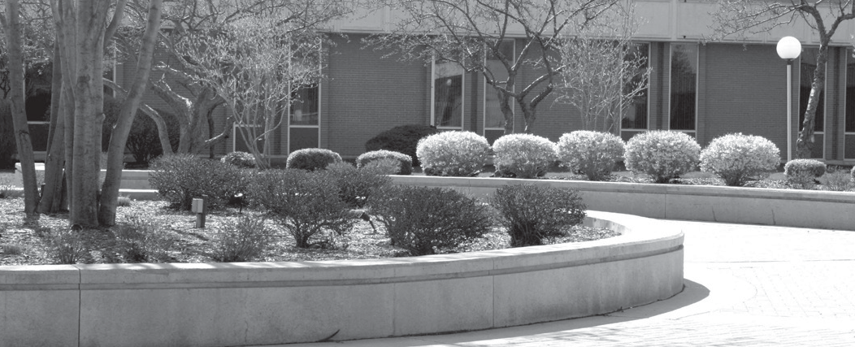

**INTRODUCTION**

Title II of the Americans with Disabilities Act (1990), the Americans with Disabilities Amendments Act (2008), and Section 504 of the Rehabilitation Act of 1973 were designed to prevent discrimination against individuals with disabilities. To comply with this legislation, the college has developed the following policy statement on non-discrimination and harassment.

Monroe County Community College is an equal opportunity institution and

complies with all Federal and State laws and regulations prohibiting discrimination and harassment. It is, therefore, the policy of the college that no qualified person participating in a college-sponsored program, service or activity shall be discriminated against because of race, color, religion, national origin or ancestry, age, gender, marital status, disability, genetic information, sexual orientation, gender identity/expression, height, weight or veteran’s status.

It is furthermore the policy of the college that any illegal acts of discrimination or harassment of students or employees will be considered as unacceptable or

impermissible conduct. Such acts will not be condoned or tolerated by the college.

The College’s equal opportunity officer, Title IX and Section 504, and ADA compliance officer for student discrimination and harassment is the vice president of enrollment management and student success, Monroe County Community College, 1555 South Rasinville Rd., Monroe, Michigan 48161, (734) 384-4255.

Monroe County Community College 1555 S. Raisinville Rd

Monroe, Michigan 48161

734-384-4167



#5703 - 10/25

**PROCEDURES FOR**

# FILING A COMPLAINT

The following procedure provides for a prompt and equitable resolution of a complaint alleging a violation of the ADA or Section 504.

* Any person participating in a Monroe County Community College sponsored program or activity who believes their rights have been violated under the ADA or Section 504 of the Rehabilitation Act of 1973, should begin this process within 30 business days after the last date of the semester in which

the incident occurred. Students should make an appointment with a disability services coordinator to discuss the situation. The Disability Services Office

is located in The Student Success Center located in Founders Hall, (734) 384-4167.

* After meeting with the disability services coordinator, if the issue/complaint is not resolved to the student’s satisfaction, the student can make an appointment with the director of student success, (734) 384-4184 to further discuss the issue/complaint. This appointment must be made within 10 business

days of the meeting with the disability services coordinator. After meeting with the director of student success if the issue/complaint is still unresolved, the director will supply the student with a complaint form, which the student must complete and return to the vice president of enrollment management and student success. The vice president’s office is located in the Warrick Student Center S -133, (734) 384-4224.

* The form must include a detailed description of the alleged discriminatory action with sufficient detail regarding the nature and specific date of the complaint. It should include the student’s request of the possible corrective actions desired from the college in regard to the complaint. The complaint shall include the complainant’s signature, student ID number and the date of when the complaint was filed.



**PROCEDURE FOR**

# REQUESTING ACCOMMODATION

Under the Americans with Disabilities Act, the Americans with Disabilities Amendments Act (2008) and the Rehabilitation Act of 1973, an individual with a disability includes any person who has a physical, learning, or psychological impairment which substantially limits one or more major life activities.

1

The student should schedule an appointment with a disability services coordinator. Eligibility for services will be determined by information gathered from the student interview and documentation provided.

2

3

Documentation and information should be provided during the initial appointment – such as accommodation history; educational or medical records; reports and assessments created by health care providers, school psychologists, teachers or an educational system. Examples

of documentation may include a psychological evaluation, 504 Plan, IEP (Individual Education Plan), SOP (Summary of Performance).

The student interview will focus on how the condition impacts the student in the academic environment. This interactive process will enable the coordinator to determine how the disability is connected to a barrier and if an accommodation would provide access.

5

4

Information gathered during the initial interview will be reviewed by a disability services coordinator. If recommendations are included in the documentation, they will be considered together with the total assessment, the specific program and class, and information provided by the student during the interview. Accommodations will be determined on an individual basis.

6

Within 10 business days of the initial appointment, the student will be notified of the outcome of their request by e-mail or in-person.



Students have the right to seek accommodation reconsideration within 10 business days of an accommodation request being denied. A request for reconsideration form should be completed and returned to the Disability Services Office. The form is located on the Disability Services web page. Students will receive a determination from the director of student success within 10 business days of receiving the request. If the student

7

does not agree with the decision, they can follow the procedure for filing an ADA or section 504 complaint located within this brochure.

8

All accommodations are provided free of charge. Cooperative agreements through a third party (e.g. Michigan Rehabilitation Services, Bureau of Services for Blind Persons) will be considered.

9

Prior to each semester, students need to submit a semester request for accommodation using the Accommodate Management System.

10

Non-credit students seeking accommodation must contact a disability services coordinator each time they register for a class.

11

Student confidentiality will be observed and no documentation or information will be released without the student’s written consent.

### STUDENT RESPONSIBILITIES

* Notify or leave a message with Disability Services if student will not be attending class due to a disability- related absence by calling (734) 384-4167 or sending an email to [lal@monroeccc.edu](mailto:lal@monroeccc.edu).
* Use the same procedure to notify Disability Services if student has difficulty with any accommodation (e.g. note taker, scribe, interpreter).
* Follow test accommodation procedures as indicated by Disability Services guidelines.

**Reasonable attempts will made to accommodate individual needs. However, this is not a guarantee that services will be provided exactly as requested.**

***(Adapted from the Association of Higher Education and Disabilities-AHEAD Guidelines, 2012)***