PROCEDURES FOR

FILING A COMPLAINT
The following procedure provides for a prompt and equitable resolution of a complaint alleging a violation of the ADA/AA or Section 504.

- Any person participating in a Monroe County Community College-sponsored program or activity who believes his or her rights have been violated under the ADA/AA or Section 504 of the Rehabilitation Act of 1973, should begin this process within 180 business days of the incident by making an appointment with the disability services coordinator to discuss the situation. The Disability Services Office is located in Room 148 Student Success Center,
(734) 384-4167.
- After meeting with the disability services coordinator, if the issue/complaint is not resolved to the student’s satisfaction, the student can make an appointment with the vice president of Enrollment Management and Student Success, (734) 384-4224
to further discuss the issue/complaint. This appointment must be made within 10 business days of the initial meeting with the disability services coordinator. After meeting with the vice president of Enrollment Management and Student Success
if the issue/complaint is still unresolved, the vice president will supply the student with a complaint form, which the student must complete and return to the ADA/AA compliance officer/director of Human Resources. The Human Resources Office is located in the Warrick Student Services/Administration Building, (734) 384-4245.
- The complaint must be in writing and include the complainant’s name and address. It must give a detailed description of the alleged discriminatory action with sufficient detail regarding the nature and specific date of the complaint. It should include the student’s request of the possible corrective actions he/she desires from the college in regard
to the complaint. The complaint shall include the complainant’s signature, student ID number and the date of when the complaint was filed.

INVESTIGATION AND RESOLUTION
Upon receipt of the complaint, the ADA/AA compliance officer/Director of Human Resources will conduct an investigation into the alleged complaint.
All parties related to the complaint will be afforded opportunity to submit evidence (including statements from witnesses) relevant to the complaint. The investigation will be completed within 10 business days and a resolution will be issued by the ADA/AA compliance officer/Director of Human Resources.

APPEAL
The complainant may request reconsideration of the complaint in the form of an appeal if he/she is dissatisfied with the outcome of the resolution. A written request for reconsideration of the outcome of the resolution should be filed in the Office of the President within five business days of receipt of the original resolution. The president will review the
request and issue a final resolution within 10 business days. The Office of the President is located in Room
127 of the Warrick Student Services/Administration Building, (734) 384-4166.

Monroe County Community College is accredited by the Higher Learning Commission.For more information, visit www.hlcommission.org or
call 800-621-7440.
Monroe County Community College is an equal opportunity institution and adheres to a policy that no qualified person shall be discriminated against because of race, color, religion, national origin or ancestry, age, gender, marital status, disability, genetic information, sexual orientation, gender identity/ expression, height, weight or veteran’s status in any program or activity for which it is responsible.
The college’s Equal Opportunity Officer and Title IX and Section 504/ ADA Coordinator and Compliance Officer for discrimination and sexual
harassment is the Director of Human Resources, Monroe County Community College, 1555 S. Raisinville Road, Monroe, MI 48161, phone 734-384-4245.

Disability Services Coordinator
(734) 384-4167 / Office: F-148

Vice President of Enrollment Management and Student Success
(734) 384-4224 / Office: Administration Building

ADA Compliance Officer Director of Human Resources
(734) 384-4245 / Office: Administration Building

#5703 - 12/20

IMPORTANT INFORMATION FOR

STUDENTS WITH DISABILITIES
ADA/AA/Section 504 Procedures for Requesting Accommodations
Procedures for Filing a Complaint

Disability Services
Monroe County Community College 1555 S. Raisinville Rd
Monroe, Michigan 48161
734-384-4167

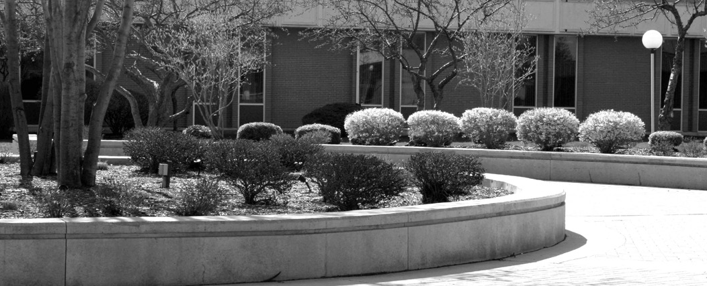PROCEDURE FOR
INTRODUCTION
Title II of the Americans with Disabilities Act (1990), the Americans with Disabilities Amendments Act (2008), and Section 504 of the Rehabilitation Act of 1973 were designed to prevent discrimination against
individuals with disabilities. To comply with this legislation, the college has developed the following policy statement on non- discrimination and sexual harassment.
Monroe County Community College is an equal opportunity institution and
complies with all Federal and State laws and regulations prohibiting discrimination and sexual harassment. It is, therefore,
the policy of the college that no qualified person participating in a college-sponsored program, service or activity shall be discriminated against because of race, color, religion, national origin or ancestry, age, gender, marital status, disability, genetic information, sexual orientation, gender/identity, expression, height, weight or veteran’s status.
It is furthermore the policy of the college that any illegal acts of discrimination or sexual harassment of students or employees will be considered as unacceptable or impermissible conduct. Such acts will not be condoned or tolerated by the college.
The college’s equal opportunity officer, Title IX and Section 504, and ADA/AA compliance officer for discrimination and sexual harassment is the director of human resources, Monroe County Community College, 1555 South
Raisinville Rd. Monroe, Michigan 48161, (734) 384-4245.

REQUESTING ACCOMMODATION
Under the Americans with Disabilities Act, the Americans with Disabilities Amendments Act (2008) and the Rehabilitation Act of 1973, an individual with a disability includes any person who has a physical, learning, or psychological impairment which substantially limits one or more major life activities.
1
The student should schedule an appointment with a disability services counselor. Eligibility for services will be determined by information gathered from the student interview and documentation provided.
2
Documentation and information should be provided during the initial appointment – such as accommodation history; educational or medical records; reports and assessments created by health care providers, school psychologists, teachers or an educational system. Examples
3
of documentation may include a psychological evaluation, 504 Plan, IEP (Individual Education Plan), SOP (Summary of Performance).
The student interview will focus on how the condition impacts the student in the academic environment. This interactive process will enable the counselor to determine how the disability is connected to a barrier and if an accommodation would provide access.
4
Information gathered during the initial interview will be reviewed by the Disability Services Review Committee. If recommendations are included in the documentation, they will be considered together with the total assessment, the specific program and class, and information provided by the student during the interview.
5
Accommodations will be determined on an individual basis.

Within 10 business days of the initial appointment, the student will be notified in writing of the outcome of their request either by mail or in person.
6
It is the responsibility of the student receiving accommodation to:
7
- Notify or leave a message with Disability Services if he/she will not be attending class due to a disability-related absence by calling (734) 384-4167.
- Use the same procedure to notify Disability Services if he/she has difficulty with any accommodation (i.e. note taker, scribe, interpreter).
- Follow test accommodation procedures as indicated by Disability Services guidelines.
All accommodations are provided free of charge. Cooperative agreements through a third party (i.e. Michigan Rehabilitation Services, Bureau of Services for Blind Persons) will be considered.
8
Loaned equipment must be returned to the Disability Services Office within one week of the end of the semester. Failure to return equipment will result in a financial hold on the student’s record.
9
Prior to each semester, students need to contact a disability services counselor to review their approved accommodations.
10
Non-credit students seeking accommodation must contact a disability services counselor each time they register for a class.
11
Student confidentiality will be observed and no documentation or information will be released without the student’s written consent.
12
Reasonable attempts will be made to accommodate individual needs. However, this is not a guarantee that services will be provided exactly as requested.
(Adapted from the Association of Higher Education and Disabilities-AHEAD Guidelines, 2012)

